Specification: at the bottom

repress, suppress, oppress surpass

resort to 依靠，求助于；诉诸；常去

resort n. 凭借，手段；度假胜地；常去之地 => interesting places

vi. 求助，诉诸；常去；采取某手段或方法

headline n. 大标题；内容提要；栏外标题；头版头条新闻 headline news

vt. 给…加标题；使成为注意中心；大力宣传

heading n. 标题；（足球）头球；信头

extract vt. 提取；取出；摘录；榨取

n. 汁；摘录；榨出物；选粹

bias n. 偏见；偏爱；斜纹；乖离率vt. 使存偏见adj. 偏斜的adv. 偏斜地

Don't let her insults bias you against your husband

prominent adj. 突出的，显著的；杰出的；卓越的

submerge vt. 淹没；把…浸入；沉浸

vi. 淹没；潜入水中；

distinction n. 区别；差别；特性；荣誉、勋章

wig:假发

obscure adj. (语言、文体等))模糊的；晦涩的；昏暗的 《==》 模糊不清的 (有道)

vt. 遮掩；使变暗；使难理解

trip , strip, stripe, strap

ditch vt. 在…上掘沟；把…开入沟里；[俚]丢弃

vi. 开沟；掘沟

n. 沟渠；壕沟

pitch vi. 倾斜；投掷；搭帐篷；坠落

vt. 投；掷；定位于；用沥青涂；扎营；向前倾跌

n. 沥青；音高；程度；树脂；倾斜；投掷

neutral

lamp damp dam lamb=>mutton(羊肉)

camel

steering wheel, steer clear of

preface foreword prologue

tap, pat, clap:拍手

outlet, outset (at the outset)

conspiracy 英[kən'spɪrəsɪ] 美[kən'spɪrəsi]n. 阴谋；共谋；阴谋集团

Assure sb that, ensure that

zebra | 'zibrə |crossing

commemorate monument: monument is a structure(usually cylindrical) erected to commemorate sth/sb

memorial 美[mɪ'morɪəl]n. 纪念碑，纪念馆；纪念仪式；纪念物adj. 记忆的；纪念的，追悼的

unanimously jʊ'nænəməs

I want to improve my endurance, I can’t bear/endure/tolerate/abide you

wretched 可怜的，悲惨的 令人讨厌的；肮脏的； 质量很差的

denounce:

erode corrode

Use routing engine to route request for web form and wcf service.

Mvc use routing engine to direct request to our controllers

We give the routing engine a map to follow(map, follow:遵照)

The words inside those curly braces will be the parameter names({controller}/{action})

This allows us to hook into application level event like application_start

has now been factored into classes that are in this app start folder

what the routing engine will do is evaluate each mapped route that we place into the route collection the first one that matches the URL will win

it coordinates with route engine behind the scene

Desktop was powered off.  Have powered back on

**be up to no good[想启用英文朗读功能吗？请先安装flash插件！](http://www.adobe.com/shockwave/download/download.cgi?P1_Prod_Version=ShockwaveFlash)**尽干坏事, 不怀好意

track down a problem

beholder=>spectator stand aside , look with folded arms

continue down: 一直延续下来;这样继续下去

I need to run a personal errand and will be out of the office from about 9:30 to 10:30 or so.

Exceed WCF message quota

I have an appointment at 10:00 this morning and a delivery that I need to sign for this afternoon so I will be working from home today.

keep to oneself 保密

speakerphone is a telephone that has a microphone and a loudspeaker, allowing you to talk to someone without putting the phone to your ear, as well as allowing other people to hear the person you are talking to. 免提电话 => take me off speakerphone

lollipop

referee is a person who gives you a reference, for example when you are applying for a job. 介绍人; 推荐人 => referral 被推举的人

Gold digger

packing tape包装胶带

[at your disposal](app:dsdetail:at%20your%20disposal) 任意使用；任你自由支配；听你差遣 as you like: 随便你….

get the edge 掌握优势

bulge v.n: 胀；膨胀；凸出部分 bulging bulged: 凸出的

When you strike up a conversation or friendship with someone, you begin one. 开始 (谈话); 建立 (友谊)

burglarize

[a puff of smoke](app:ds:a%20puff%20of%20smoke)一阵烟

[a puff of wind](app:ds:a%20puff%20of%20wind)一股风

gravy boat： sauce boat

editor window:编辑窗口(vs.net)

debugger … to step through code and inspect variable values

put a break point by ….. we hit the break point

F10 to step through code one line at a time

and so forth: 等等

code snippet in vs.net

turn over the soil :翻地(梨田)

a poorly illuminated room

action filter are components that you want to use to apply cross-cutting logic that’s logic has to execute across multiple controller action but you don’t want to duplicate the codes inside individual controller actions

twiddle with摆弄 抚弄 玩弄

trivia trifle, trifle with: 玩弄

trophy奖品 奖杯

if you wiggle something or if it wiggles, it moves up and down or from side to side in small quick movements. 摆动; 扭动—老友记里，joe 被门卡住了—wiggle him out

pit against: 竞争

baton ˈbætən指挥棒

allude **əˈlud**

requisite:必需品， 必备的，不可少的

flagstone paving stone mosaic:马赛克

ceramic tile 英[sɪ'ræmɪk][想启用英文朗读功能吗？请先安装flash插件！](http://www.adobe.com/shockwave/download/download.cgi?P1_Prod_Version=ShockwaveFlash) 美[sə'ræmɪk] [想启用英文朗读功能吗？请先安装flash插件！](http://www.adobe.com/shockwave/download/download.cgi?P1_Prod_Version=ShockwaveFlash)

contiguous number

imperative [im'perətiv]

**adj.**1. 必要的；不可避免的；迫切的，紧急的

2. 命令的；专横的；强制的 3. 有控制力的，有抑制力的

**n.**1. 必须做的事，必须履行的责任；必要的事；紧急的事；需要，必要性

2. 命令；规则3. 【语法学】 祈使语气

Combat kəmˈbæt**名词读作ˈkɒmbæt。动词读作kəmˈbæt**

Combatant [美][kəmˈbætn:t

Novice , rookie,, newbie

A novice is someone who has been doing a job or other activity for only a short time and so is not experienced at it.

sidestep

If one person is at another's beck and call, they have to be constantly available and ready to do whatever is asked, and this often seems unfair or undesirable. 随时待命

Rachel says: I want you to be at my constant beck and call, 24 hours a day

Beckon **ˈbekən** 召唤；招手If you beckon to someone, you signal to them to come to you. 向…招手

Backlog

1. percent lower

brazen ['breɪz(ə)n][想启用英文朗读功能吗？请先安装flash插件！](http://www.adobe.com/shockwave/download/download.cgi?P1_Prod_Version=ShockwaveFlash) 美['brezn][想启用英文朗读功能吗？请先安装flash插件！](http://www.adobe.com/shockwave/download/download.cgi?P1_Prod_Version=ShockwaveFlash) adj. 厚颜无耻的；黄铜制的

barge in :闯入，干扰 swoop in:

gut-wrenching pain: 揪心的痛

jeopardize: 危害

down payment：首付

muffle : vt. 蒙住；裹住；抑制；发低沉的声音 n. 低沉的声音；消声器；包裹物（如头巾，围巾等）；唇鼻部

put oneself out：费力，努力

you don’t know how it feels like if you put yourself out and get shot down(否决)

* end things on good terms: 平安无事 keep / be on good terms保持友好关系

Here is our current timeline after talking with Kirill 限期,年表

Miraculous, marvelous,

Love out of wedlock

Shortsighted-ness nearsighted-ness, myopic, myopia maɪ'əʊpɪə

Joe: there’s a 15-minute line for buffet, and I slipped on a booger, I wiped it on chandler’s

Clothes. Snot: 鼻涕

If in 25 years, I am half as happy as you are…..

Crab move sideways

People or things that are interdependent all depend on each other. 互相依赖的

Glare at, stare at, gaze at …….

decimal place: 小数位 , the third decimal place小数点后第三位

for their own use 为己所用

in inverse proportion to

invert 倒转,倒置（前后，上下）, inverse(相反的,inverse proportion .反比,使倒转), reverse(reverse the string), converse(交谈，逆行的，相反的)，, controversy（争辩）

acquire, obtain, attain(也有达到某地的意思), achieve, gain

Preclude … from …

Sparkle =>If a star or a light twinkles, it shines with an unsteady light which rapidly and constantly changes from bright to faint. 闪烁

The sprint is a short, fast running race. 短跑赛

A sprint is a fast run that someone does, either at the end of a race or because they are in a hurry. 冲刺; 快跑

Coerce kəu'ə:s

If something is superseded by something newer, it is replaced because it has become old-fashioned or unacceptable. 取代

As many scenarios as possible

Myth mythology mythologic

Knuckle Knuckle under/down

get an electric shock

officious 多管闲事的；非官方的

Something, especially something bad, that is pervasive is present or felt throughout a place or thing. (尤指不好的事物) 无处不在的 普遍的；到处渗透的 pə'veɪsɪv

If something pervades a place or thing, it is a noticeable feature throughout it. 弥漫; 充满

You have to know up front(预先；在最前面) that…..

Italicize ɪ'tælɪsaɪz用斜体字排字；强调 italic

Backward compatibility

Menace 英['menəs][想启用英文朗读功能吗？请先安装flash插件！](http://www.adobe.com/shockwave/download/download.cgi?P1_Prod_Version=ShockwaveFlash) 美['mɛnəs] n,v: 威胁；恐吓[想启用英文朗读功能吗？请先安装flash插件！](http://www.adobe.com/shockwave/download/download.cgi?P1_Prod_Version=ShockwaveFlash)

As few base classes as possible

Back in the early days of computers..

One application stall the other application in one thread OS

virtual address space 虚地址空间

Suffice it to say ：简单地说，可以这样说simply speaking /in short, / in brief

Responsiveness:响应能力

Cup at full speed

This also means that there is an average of approximately 13.8 threads for each process.

Use thread Sparingly（'spɛrɪŋ） :节约地用 thrift thrifty thriftily

Preempt If you preempt an action, you prevent it from happening by doing something that makes it unnecessary or impossible. 预先制止 or 先占；先取；以先买权获得

Preemptive adj. 优先购买的；先发制人的；有先买权的

with respect to, clr(2 methods run asynchronously with respect to one another )

需要花费大量时间运算上的操作,我们将其称作"**Compute-Bound Operation**",

Spawn spɔn n. 卵；菌丝；产物vt,vi. 产卵；酿成，造成；大量生产

In probation period 英[prə'beɪʃ(ə)n][想启用英文朗读功能吗？请先安装flash插件！](http://www.adobe.com/shockwave/download/download.cgi?P1_Prod_Version=ShockwaveFlash) 美[pro'beʃən]

bath cream body wash

Pyramids are ancient stone buildings with four triangular sloping sides. The most famous pyramids are those built in ancient Egypt to contain the bodies of their kings and queens. 金字塔

Saturate : vt. 浸透，使湿透；使饱和，使充满adj. 浸透的，饱和的；深颜色的

Saturating:

Contention: n. 争论，争辩；争夺；论点 ,thread contention:线程争用(竞争)

Scandal, sandal

Slingshot:弹弓 crossbow: 弩

An icicle ˈaɪsɪkəl is a long pointed piece of ice hanging down from a surface. It forms when water comes slowly off the surface , and freezes as it falls. 冰锥

Stop Propagation [,prɑpə'geʃən

Radix: n. 根；[数] 基数 A base is a system of counting and expressing numbers. The decimal system uses base 10, and the binary system uses base 2. 基数 system有方法的意思

Raisins are dried grapes. 葡萄干

On a per view basis

Match up … with

And one of the reasons this was so easy to build is because we're using TryUpdateModel

which just relies on the names of properties to match up data with what needs to get pushed into the model.

It used to be inside of a foreach loop that had a local variable called item

it's very difficult to tie it to any particular model

Because like all public methods on the controller, if the user enters the right URL into the browser, they're going to be able to invoke the controller action

Post operations are write operations

On the count of three, we run: 我数到三

Discreet [dɪ'skrit], discretion: 谨慎的；小心的 prudent

Tier: tɪə n. 层，排；行，列；等级 tier one: 一级

thus far = so far

[bath](app:ds:bath) [mat](app:ds:mat) non-slip mat parking lot, side mirror == rearview mirror

Your second cousins are the children of your parents' first cousins. Compare . 第二代堂兄妹; 第二代表兄妹; 与first cousin比较

工作英语词汇

ministry of labor 劳工部 (美作:department of labor)  
labor market 劳工市场, 劳务市场  
labor exchange, employment exchange 职业介绍所 (美作:employment bureau)  
piecework work 计件工作  
timework work 计时工作  
teamwork work 联合工作  
shift work 换班工作  
handicrafts, crafts 手艺, 技艺  
work contract 劳务合同  
industrial accident 劳动事故；工伤事故  
occupational disease 职业病 industrial disease  
vocational guidance 职业指导  
vocational training 职业训练  
retraining, reorientation, rehabilitation 再训练, 再培训  
holidays, holiday, vacation 假期  
receptionist 接待员  
typist 打字员  
shorthand typist 速记打字员  
public servants 公务员  
national public servant 国家公务员   
tracer 绘图员  
journalist 记者  
interpreter 通译者  
director 导演  
talent 星探  
philosopher 哲学家  
politician 政治学家  
physicist 物理学家  
geologist 地质学家  
expert on folklore 民俗学家  
mathematician 数学家  
biologist 生物学家  
statistician 统计学家  
artists 艺术家  
painter 画家  
composer 作曲家  
dressmaker 女装裁剪师  
cutter 裁剪师  
sewer 裁缝师  
tailor 西装师傅  
beautician 美容师 bjuː'tɪʃ(ə)n  
model 模特  
detective 刑警  
mailman 邮差  
bootblack 擦鞋童 =》 shoeblack a person who shines boots and shoes shine:擦亮  
newscaster新闻广播员 newsreader  
florist 卖花人 'flɔrɪst  
baker 面包师 farmers market: 农贸市场  
greengrocer 菜贩 grocer, grocery greengrocer’s : 蔬菜水果店 =>greengrocery  
fish-monger 鱼贩 monger: 商人; 贩子  
butcher 肉贩  
saleswoman 女店员  
stewardess 空中小姐  
station agent 站长  
porter 行李夫  
architect 建筑师  
civil planner 城市设计师  
druggist,, pharmacist 药剂师  
supervisor 监工

enlighten => inspire

To enlighten someone means to give them more knowledge and greater understanding about something. 启迪 enlightened: 开明的；文明的；进步的；被启发的  
in a reverse order

appraise (appraise at $10)=> assess , praise, express approval to sb

When experts appraise something, they decide how much money it is worth. 估价

If you appraise something or someone, you consider them carefully and form an opinion about them. 评价

indulge, condone

indulge in sth

A spiral is a shape which winds around and around, with each curve above or outside the previous one. 螺旋形(的) 'spaɪrəl

Hash sign = pound sign

读音:Alphabet美]**[ˈælfəˌbɛt, -bɪt]** majority parenthesis =>parentheses

Broccoli 'brɑkəli 西兰花 is nutritious or nourishing

stopwatch 英['stɒpwɒtʃ][想启用英文朗读功能吗？请先安装flash插件！](http://www.adobe.com/shockwave/download/download.cgi?P1_Prod_Version=ShockwaveFlash) 美['stɑpwɑtʃ][想启用英文朗读功能吗？请先安装flash插件！](http://www.adobe.com/shockwave/download/download.cgi?P1_Prod_Version=ShockwaveFlash)n. 码表；跑表 timer

latency:延迟 'letnsi

travel long distances and wind their way through different pieces of hardware

this two connection limitation is per host, per host name

network congestion[想启用英文朗读功能吗？请先安装flash插件！](http://www.adobe.com/shockwave/download/download.cgi?P1_Prod_Version=ShockwaveFlash) 网络拥挤 [计] 网络拥塞 traffic congestion

most servers will be configured to close a persistent connection if it’s idle for a period of time

conscienceless

A persistent cookie is the other type of cookie and it can outlive a single browsing session

When you sniff, you breathe in air through your nose hard enough to make a sound, for example, when you are trying not to cry, or in order to show disapproval. 抽鼻子 (用来忍住哭声或表示不赞同)

A jumble of things is a lot of different things that are all mixed together in a disorganized or confused way. 杂乱的一堆

If you jumble things, they become mixed together so that they are untidy or are not in the correct order. 混杂

Someone or something that is vibrant is full of life, energy, and enthusiasm. 充满活力的

Spat: 口角

Customary 习惯的；通常的

If someone is empowered to do something, they have the authority or power to do it. 授权

Smother: 使窒息 muffle: 蒙住（蒙住…的头(使看不见东西)；捂住…的嘴(使不出声)： ），压低 (声音)

When something is imprinted on your memory, it is firmly fixed in your memory so that you will not forget it. 铭刻

Willpower is a very strong determination to do something. 毅力

48 hours lockdown, and the next time would be one week, the time after that would be one month

we've had 14 consecutive quarters of GDP growth above 3%

synchronized section

use it to keep an application from being started twice

erratic

Academic record/achievement fall behind

A knapsack is a cloth or leather bag that you carry on your back or over your shoulder, for example when you are walking in the countryside. 背包

rough up[想启用英文朗读功能吗？请先安装flash插件！](http://www.adobe.com/shockwave/download/download.cgi?P1_Prod_Version=ShockwaveFlash) v. 粗暴对待；殴打；对…动粗

synonym 'sɪnənɪm

walk away unharmed

If there is a discrepancy between two things that ought to be the same, there is a noticeable difference between them. 差异

Ruffian A ruffian is a man who behaves violently and is involved in crime. 恶棍; 歹徒

rogue

Reluctant, redundant, superfluous

Sever: ˈsɛvə chandler got a severed toe on his right foot

To sever something means to cut completely through it or to cut it completely off. 切断; 切掉

Legislature ˈledʒɪˌsleɪtʃə 立法机关；立法机构 legitimate liˈdʒitimit **美**[ləˈdʒɪtəmɪt]

**orphanage ['ɔ:fənidʒ] [想启用英文朗读功能吗？请先安装flash插件！](http://www.adobe.com/shockwave/download/download.cgi?P1_Prod_Version=ShockwaveFlash)**n. 孤儿院；孤儿身份

If a place is airless, there is no fresh air in it. 不通风的; 无新鲜空气的

=>nonventilated, unventilated

You will have a lot more to worry about than an angry boss.

I want nothing more than to go back home

Shoot=> eject=>spray(喷口)=>spout <= => sprout

体积： volume; bulk

Innovation

有道： strain, stress, pressure(blood ~)

Rash(轻率的；鲁莽的；n. [皮肤] 皮疹) => thoughtless, imprudent, indiscreet) discreet 🡸🡺 discrete

inverted comma=> quotation mark

A streak is a long stripe or mark on a surface which contrasts with the surface because it is a different colour. 条纹

That is, given an argument x, the natural logarithm returns the power to which e must be raised to give the value x.[想启用英文朗读功能吗？请先安装flash插件！](http://www.adobe.com/shockwave/download/download.cgi?P1_Prod_Version=ShockwaveFlash)

也就是给定一个参数 x，该自然对数返回 e 的几次幂等于给定的值 x。

Raise 4 to the third power

1. The perimeter pə'rɪmɪtɚ of an area of land is the whole of its outer edge. 周边; 周界

...the perimeter of the airport.

…机场周边。

on sight

reflecton on/upon: 仔细考虑，思考；反省；回想，回顾；怀疑

cross site scripting

ampersand=>&

@@data to escape at sign

And opening curly brace and closing curly brace , square bracket, parentheses, angle bracket

But those are edge cases you probably won't run into this very often

Cascading style sheet

TryUpdateModel just relies on the names of properties to match up data

And all of that matches up because our edit view is using things like HTML.EditorFor(that’s a significant reason why we use html helper), which(html helper) will automatically build the correct inputs with the right names and the IDs and the validation and everything else associated with it

Intellisense window

introspect **/ˌɪntrəˈspɛkt/** to examine and analyse one's own thoughts and feelings 内省; 自省

And for each iteration of the loop

Ajax: I completely lose my scroll position

If U  **impede** someone or something, you make their movement, development, or progress difficult.阻碍Someone's **prowess ˈpraʊɪs**  is their great skill at doing something. 杰出的技能

I am not gonna let him score 5 points today

Do a case sensitive search , do a case insensitive search

A **plaster** is a strip of sticky material used for covering small cuts or sores on your body. 膏药

**Plaster** is a smooth paste made of sand, lime, and water that gets hard when it dries.

**Paste** is a soft, wet, sticky mixture of a substance and a liquid, that can be spread easily. Some types of paste are used to stick things together. 面团; 糨糊

If you **paste** something on a surface, you put glue or paste on it and stick it on the surface. (用胶水或糨糊) 粘贴

If you make an **accusation** against someone, you criticize them or express the belief that they have done something wrong. 指责

 When you **tickle** someone, you move your fingers lightly over a sensitive part of their body, often in order to make them laugh. 胳肢

Absolve from : GC absolve developers from having to track memory usage and when to free….

We will see this shortly(马上)

**Fatigue** is a feeling of extreme physical or mental tiredness. 疲惫

敬酒：[propose](javascript:void(0);) [a](javascript:void(0);) [toast](javascript:void(0);) toast有土司的意思

**Mercury** is a silver-coloured liquid metal that is used especially in thermometers . 水银

**Net** is a kind of cloth that you can see through. It is made of fine threads woven together so that there are small equal spaces between them. 网

deck of cards

**Spades** is one of the four suits in a deck of playing cards => club 梅花，diamond, heart

oil fume extractor

endure, stand, tolerate, put up with, bear： 忍受

If someone **extorts** **ɪkˈstɔːt**  money **from** you, they get it from you using force, threats, or other unfair or illegal means. 勒索

Carriage: 除马车和运费外，还有火车车厢(train carriage)的意思， compartment

Triumph: 胜利，凯旋；欢欣 , triumph over:击败

you use **wicked** to describe someone or something that is very bad and deliberately harmful to people. 邪恶的

sincere: 真诚的，诚恳的 诚实的，忠实的

路标：road sign; route marking; route sign route map: 线路图

Shell:有脱壳，去壳的意思 shed: many meanings, like: 摆脱，流出，脱掉(cast off skin)n. 小屋，棚

Hold a mug at an angle(斜着拿,倒水)

 In mathematics, a **prime number** is a whole number greater than 1 that cannot be divided exactly by any whole number except itself and the number 1, such as 17. 质数; 素数

Wade through:涉水（泥泞等）；费力地做完；艰难地通过

You may need to wade through the markup of you entire window

All conditions must be met before multi-trigger springs into action

If someone **revamps** something, they make changes to it in order to improve it. 修改; 改进

A marketplace is a small area in a town or city where goods are bought and sold, often outdoors. 集市

Since EF isn't built in to .NET as of EF 6

an additional assembly that's distributed using NuGet

Legible writing is clear enough to read. (字迹)清晰可辨的

Include Related(EF designer) will only pull in entities that are directly related to the one you started with

create a problem down the road(将来会有问题)

When something such as a plane, car, or building has been destroyed, you can refer to what remains as **wreckage** or **the wreckage**

Desolate,bleak:荒凉的 obsolete: 废弃的；老式的

Curricula kə'rɪkjələ=>单数：curriculum

anonymously typed object

toggle class alternates adding or removing a class based on the presence or absence of the class

**dysfunction**

intangible tangle:缠在一起… tangible:有形的

## impede=>impediment ɪm'pedɪm(ə)nt

If you **delve** **into** something, you try to discover new information about it. 探索

Havoc ['hævək]: 大破坏；浩劫

Coalesce, coalescing operator => ??

He would hold his fingers about 1 centimeter apart and announce "I'm this close."

the **locus of** something is the place where it happens or the most important area or point with which it is associated. 发生地; 相关点 locust:蚱蜢

prescribed points: 规定的点 prescribe:规定，开药方的意思

A **rhythmic** movement or sound is repeated at regular intervals, forming a regular pattern or beat. 有节奏的(good)

Often a view needs to display a variety of data that doesn’t map directly to a domain model. One approach you might take is to write a custom view model class. You can think of a view model as a model that exists just to supply information for a view.

This ability for Razor to automatically transition back from code to markup is one of its big appeals

and is the secret sauce in keeping the syntax compact and clean. However, it may make some of you

worry that ambiguities(歧义) can occur.

Terse=>compact=>concise terseness, conciseness

demarcate 美 ['dimɑr'ket] vt. 划分界线；区别

 If you **demarcate** something, you establish its boundaries or limits

 If you **delimit** something, you fix or establish its limits. 定界限 delimiter:分界符

code blocks require curly braces to delimit the block of code in addition to an @ sign

If a set of views shares common settings, the _ViewStart.cshtml file is a useful place to consolidate these common view settings.

If you describe a person or a piece of writing as **verbose**, you are critical of them because they use more words than are necessary, and so make you feel bored or annoyed. 罗嗦的

Boilerplate ˈbɔɪləˌpleɪt 样板文件；引用

Model binding isn’t restricted to HTTP POST

Byproduct: 副产品

Elegant: 优雅的

Html helpers keep you *close to metal* while remaining productive.

You can set as many attribute values using the htmlAttributes parameter as necessary.

if a user clicks the label, the browser will transfer focus to the associated input control. This is especially useful with checkboxes and radio buttons in order to provide the user with a larger area to click on

grunge ɡrʌndʒ 乏味的东西；难看的东西

If no values match Album.Price in ViewData, the helper attempts to look up a value for the portion

of the name before the first dot, (Album), and in this case finds an object of type Album. The helper

then evaluates the remaining portion of the name (Price) against the Album object, and finds the

value to use.

@Html.TextBox("Title", Model.Title) //不能 @Html.TextBox("Title"), why? please see blow

If you invoked the TextBox helper passing only the string Title, it would fi rst look

in the ViewBag and pull out the Title value inside (the helpers look inside the ViewBag before they

check the strongly typed model). To display the proper title, you need to provide the explicit value in this case.

Assort: 把…分级；把…归为一类;(with)搭配(如颜色), an assortment of :各种各样的

replacing strings with lambda expressions provides a number of additional benefits. The

benefits include IntelliSense, compile-time error checking, and easier refactoring (if you change the

name of a property in your model, Visual Studio can automatically change the code in the view).

With the attribute in place, if the customer tries to submit the form without providing a last name,

he’ll see the default error

giga => gigabytes:十亿字节 gigə

the MVC Music Store database schema sets the maximum length for a name at 160 characters

The StringLength attribute can ensure the string value provided by the customer will fit in the database:

Litter: be littered with 充满 a litter of :一窝(小动物) litter=>garbage or waste 垃圾

消毒:Disinfect, sanitize(sanitation,sanitary), sterilize(还有”使绝育”的意思)

 If you say that something is **amiss**, you mean there is something wrong. 出差错的 go amiss:出错了

**hapless**  => unlucky

witting:故意的 unwitting:不知情的， unwittingly:不知不觉的

ASP.NET MVC Model Binding is a powerful feature that greatly simplifies the process handling

user input by automatically mapping the input to your model properties based on naming convention

intrude(into): 闯入，侵入,打扰 barge into: 闯入 invader

mosaic [mo'zeɪk

erroneous **ɪˈrəʊnɪəs**

graft: 移植，嫁接 **美**[ɡræft]

fraudulent ˈfrɔdʒələnt

grove:小树林，小树丛 grəʊv

 If a situation or action is **fraught with** problems or risks, it is filled with them. 充满 (问题或风险) 的

If you say that a situation or action is **fraught**, you mean that it is worrisome or difficult. 令人担忧的

 When a number of people **chip in**, each person gives some money so that they can pay for something together.

A **lotus** ['ləʊtəs] or a **lotus flower** is a type of water lily that grows in Africa and Asia. 莲花

cut sb some slack 放某人一马 cut joe some slack

Mark said: The code red is active (see attached) and all non-prod VMS’s have very spotty connectivity / response.

Household: 家庭的，日常的n:家庭 household chores(琐事)/articles/objects/goods(用品)/appliance(家庭电器)/service(家庭服务)

分辨率是resolution（有决心，决议的意思）,不是solution

Dedicate and delicate: do it in a delicate way / I dedicate my time to the project

Ps: 附言=>postscript

Cruise, courier

 If you refer to an untrue statement as a white lie, you mean that it is made to avoid hurting someone's feelings or to avoid trouble, and not for an evil purpose. 善意的谎言

Please be aware that Dallas has switched to Daylight Savings Time yesterday, Sunday, March 9, 2014. The time difference is now +/- 13 hours.

When the routing engine picks apart a URL into these pieces it builds up a data structure

Portugal 'pɔtjuɡəl:葡萄牙 Portuguese: [ˌpɔrtʃəˈɡiz] 葡萄牙人，葡萄牙语

the Netherlands:荷兰 , Netherlander: 荷兰人

 A sentry is a soldier who guards a camp or a building. 哨兵; 警卫

Pseudo code英 ['sjuːdəʊ]  美 ['sʊdo]

 A cassette is a small, flat, rectangular plastic case containing magnetic tape which is used for recording and playing back sound or film. 磁带 play back:回放

Psychiatrist saɪ'kaɪətrɪst psychology ：心理学

Take a leave of absence

We will look at the building blocks of any control in wpf application. Building block:积木；构件；基础材料

#endregion English_Part

#region scrum pluralsight

Scrum teams do a little bit of all these activities on a recurring and regular basis

This is at the heart and soul of Scrum, the ability to deliver working software and then evolve it to a different state, keeping the quality high, It increases our ability to deliver working software to our customer earlier, And our risk is limited only to the cost of a single iteration

That is, with every sprint, we deliver working, usable software that helps inform the features to be added in the next sprint

Scrum has only three, a Product Backlog, Sprint Backlog, and an Increment

A Product Backlog is the single source of truth for any change to be made to the product.

The product increment or simply the increment is the result of any successful Sprint，The product increment includes all features from Product Backlog items that were done

The Sprint Backlog is essentially a plan with enough detail that the Development Team uses it throughout the Sprint to guide their decisions and assess their progress toward creating the perfect increment for that Sprint

The formal definition of a Sprint Backlog is this, the set of Product Backlog items that have been selected to be delivered in the current Sprint plus a plan

#endregion

WPF:

A style is a collection of property values that can be applied to an element. The WPF style system

plays a similar role to the Cascading Style Sheets (CSS) standard in HTML markup. Like CSS, WPF styles

allow you to define a common set of formatting characteristics and apply them throughout your

application to ensure consistency. And as with CSS, WPF styles can work automatically, target specific

element types, and cascade through the element tree. However, WPF styles are more powerful because

they can set *any* dependency property. That means you can use them to standardize nonformatting

characteristics, such as the behavior of a control. WPF styles also support *triggers*, which allow you to

change the style of a control when another property is changed

Property value inheritance is one of the many optional features that dependency properties can provide.

Styles provide the perfect solution. You can define a single style that wraps all the properties you want to set.

In some cases, you won’t be able to set the property value using a simple attribute string

In this situation, you can use the familiar XAML trick of replacing the attribute with a nested element

**BasedOn="{StaticResource BigFontButtonStyle}">**

Trigger This is the simplest form of trigger. It watches for a change in a dependency

property and then uses a setter to change the style.

MultiTrigger This is similar to Trigger but combines multiple conditions. All the conditions

must be met before the trigger springs into action.

DataTrigger This trigger works with data binding. It’s similar to Trigger, except it watches for a

change in any bound data.

MultiDataTrigger This combines multiple data triggers.

EventTrigger This is the most sophisticated trigger. It applies an animation when an event

occurs

Dependency properties use more efficient storage and support additional

features such as change notification and property value inheritance (the ability to propagate default

values down the element tree). Dependency properties are also the basis for a number of key WPF

features, including animation, data binding, and styles

WPF’s resource system is simply a way of keeping around a set of useful objects, such as commonly used

brushes, styles, or templates, so you can reuse them more easily.

Although you can create and manipulate resources in code, you’ll usually define them in your XAML

markup. Once a resource is defined, you can use it throughout the rest of the markup in your window

(or, in the case of an application resource, throughout the rest of your application). This technique

simplifies your markup, saves repetitive coding, and allows you to store user interface details (such as

your application’s color scheme) in a central place so they can be modified easily. Object resources are

also the basis for reusing WPF styles, as you’ll see in the next chapter.

Every element includes a Resources property, which stores a dictionary collection of resources. (It’s an instance of the ResourceDictionary class.)

the most common way to define resources is at the window level. That’s

because every element has access to the resources in its own resource collection and the resources in all of its parents’ resource collections.

Static resources are set once, when the window is first created. Dynamic

resources are reapplied if the resource is changed

The difference is that a static resource grabs the object from the resources collection once.

Depending on the type of object (and the way it’s used), any changes you make to that object may be

noticed right away. However, the dynamic resource looks the object up in the resources collection every

time it’s needed. That means you could place an entirely new object under the same key, and the

dynamic resource would pick up your change.

To see an example that illustrates the difference, consider the following code, which replaces the

current image brush with a completely new (and boring) solid blue brush:

this.Resources["TileBrush"] = new SolidColorBrush(Colors.LightBlue);

A dynamic resource picks up this change, while a static resource has no idea that its brush has been

replaced in the Resources collection by something else. It continues using the original ImageBrush instead.

Ordinarily, when you use a resource in multiple places, you’re using the same object instance. This

behavior—called *sharing*—is usually what you want. However, it’s also possible to tell the parser to

create a separate instance of your object each time it’s used.

To turn off sharing, you use the Shared attribute, as shown here:

<ImageBrush x:Key="TileBrush" x:Shared="False" ...></ImageBrush>

WPF allows you to define these tasks—known as commands—and connect controls to them so

you don’t need to write repetitive event handling code. Even more important, the command feature manages the state of your user interface by automatically disabling controls when the linked commands aren’t available. It also gives you a central place to store (and localize) the text captions for your commands.

Wpf command:

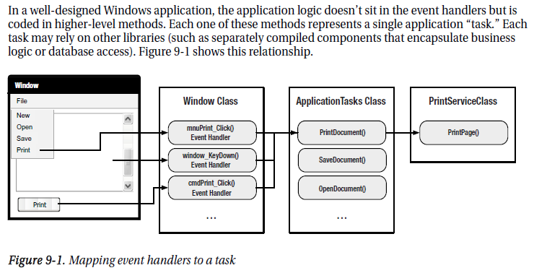

The most obvious way to use this design is to add event handlers wherever they’re needed, and use

each event handler to call the appropriate application method. In essence, your window code becomes a

stripped-down switchboard that responds to input and forwards requests to the heart of the application.

Although this design is perfectly reasonable, it doesn’t save you any work. Many application tasks

can be triggered through a variety of routes, so you’ll often need to code several event handlers that call

the same application method. This in itself isn’t much of a problem (because the switchboard code is so

simple), but life becomes much more complicated when you need to deal with user interface *state*.

A simple example shows the problem. Imagine you have a program that includes an application

method named PrintDocument(). This method can be triggered in four ways: through a main menu (by

choosing File ➤ Print), through a context menu (by right-clicking somewhere and choosing Print),

through a keyboard shortcut (Ctrl+P), and through a toolbar button. At certain points in your

application’s lifetime, you need to temporarily disable the PrintDocument() task. That means you need

to disable the two menu commands and the toolbar button so they can’t be clicked, and you need to

ignore the Ctrl+P shortcut. Writing the code that does this (and adding the code that enables these

controls later) is messy. Even worse, if it’s not done properly, you might wind up with different blocks of

state code overlapping incorrectly, causing a control to be switched on even when it shouldn’t be

available. Writing and debugging this sort of code is one of the least glamorous aspects of Windows

development.

Now each action that initiates printing (clicking the

button, clicking the menu item, or pressing Ctrl+P) is mapped to the same command. A command

binding links that command to a single event handler in your code.

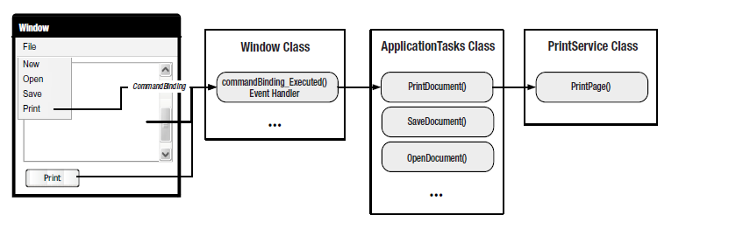

data binding is a relationship that tells WPF to extract some information from a *source*

object and use it to set a property in a *target* object. The target property is always a dependency property,

and it’s usually in a WPF element—after all, the ultimate goal of WPF data binding is to display some

information in your user interface

Interestingly, there’s a way to force values to flow in both directions: from the source to the target

and from the target to the source. The trick is to set the Mode property of the Binding Mode=TwoWay

<TextBox Text="{Binding ElementName=lblSampleText, Path=FontSize, Mode=TwoWay}">

</TextBox>

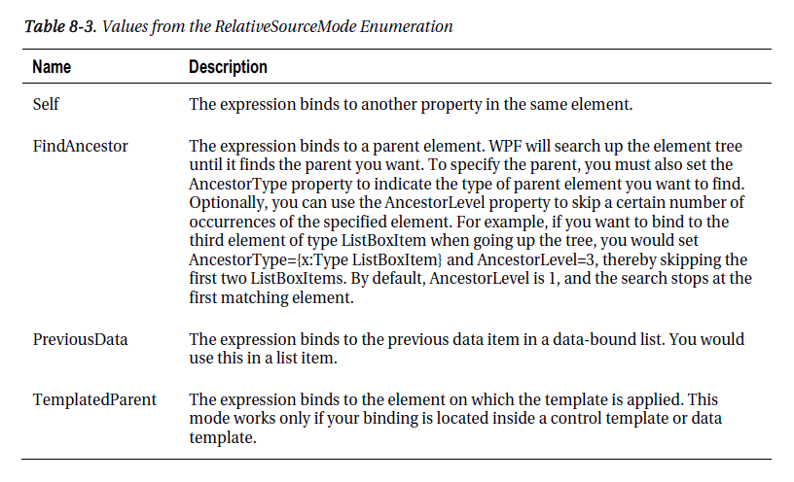

Binding to static object:

<TextBlock Text="{Binding Source={x:Static SystemFonts.IconFontFamily}, Path=Source}"></TextBlock>

<StackPanel DataContext="{x:Static SystemFonts.IconFontFamily}">

Now you can streamline your binding expressions by leaving out the source information:

<TextBlock Margin="5" Text="{Binding Path=xxxx}"></TextBlock>

When the source information is missing from a binding expression, WPF checks the DataContext

property of that element. If it’s null, WPF searches up the element tree looking for the first data context

that isn’t null. (Initially, the DataContext property of all elements is null.) If it finds a data context, it uses

that for the binding

The most important feature that WPF’s list controls provide is *UI virtualization*, a technique where the

list creates container objects for the currently displayed items only. For example, if you have a ListBox

control with 50,000 records but the visible area holds only 30 records, the ListBox will create just 30

ListBoxItem objects (plus a few more to ensure good scrolling performance). If the ListBox didn’t

support UI virtualization, it would need to generate a full set of 50,000 ListBoxItem objects, which would

clearly take more memory. More significantly, allocating these objects would take a noticeable amount

of time, briefly locking up the application when your code sets the ListBox.ItemsSource property.

ListBox, ListView, and DataGrid automatically use a VirtualizingStackPanel to lay out their children.

However, the ComboBox class uses the standard nonvirtualized

StackPanel. If you need virtualization support, you must explicitly add it by supplying a new

ItemsPanelTemplate, as shown here:

**<ComboBox>**

**<ComboBox.ItemsPanel>**

**<ItemsPanelTemplate>**

**<VirtualizingStackPanel></VirtualizingStackPanel>**

**</ItemsPanelTemplate>**

**</ComboBox.ItemsPanel>**

**</ComboBox>**

Deferred Scrolling

To further improve scrolling performance, you can switch on *deferred scrolling*. With deferred scrolling,

the list display isn’t updated when the user drags the thumb along the scroll bar. It’s refreshed only once

the user releases the thumb. By comparison, when you use ordinary scrolling, the list is refreshed as you

drag so that it shows your changing position.

As with item container recycling, you need to explicitly enable deferred scrolling:

<ListBox ScrollViewer.IsDeferredScrollingEnabled="True" ... />

Binding format:

Here’s an example that applies the format string to the UnitCost field so that it’s displayed as a

currency value:

<TextBox Margin="5" Grid.Row="2" Grid.Column="1"

Text="{Binding Path=UnitCost, StringFormat={}{0:C}}">

</TextBox>

You’ll notice that the StringFormat value is preceded with the curly braces {}. In full, it’s {}{0:C}

rather than just {0:C}. The slightly unwieldy pair of braces at the beginning are required to escape the

string. Otherwise, the XAML parser can be confused by the curly brace at the beginning of {0:C}.

Incidentally, the {} escape sequence is required only when the StringFormat value begins with a

brace. Consider this example, which adds a literal sequence of text before each formatted value:

<TextBox Margin="5" Grid.Row="2" Grid.Column="1"

Text="{Binding Path=UnitCost, StringFormat=The value is {0:C}.}">

</TextBox>

This expression converts a value such as 3.99 to “The value is $3.99.” Because the first character in

the StringFormat value is an ordinary letter, not a brace, the initial escape sequence isn’t required.

The WPF list controls also support string formatting for list items. To use it, you simply set the

ItemStringFormat property of the list (which is inherited from the base ItemsControl class). Here’s an

example with a list of product prices:

<ListBox Name="lstProducts" DisplayMemberPath="UnitCost" ItemStringFormat="{0:C}">

</ListBox>

#region pluralsight – Entity framework

ORMs are aimed to increase developer productivity by relieving you of the tedium

and redundant(不仅有多余的意思，也有冗长的意思) task of persisting the data that you use in your applications.

but the developer community is already getting involved in discussions, code review, and even submitting their own code, some of which are already been committed towards Entity Framework 6.

Entity Framework is no longer tied to the .NET release cycle

Mechanism:

You write your queries with LINQ, LINQ to entities and Entity Framework breaks those down into something called command trees Then the provider will transform the command tree into the appropriate SQL for the targeted database

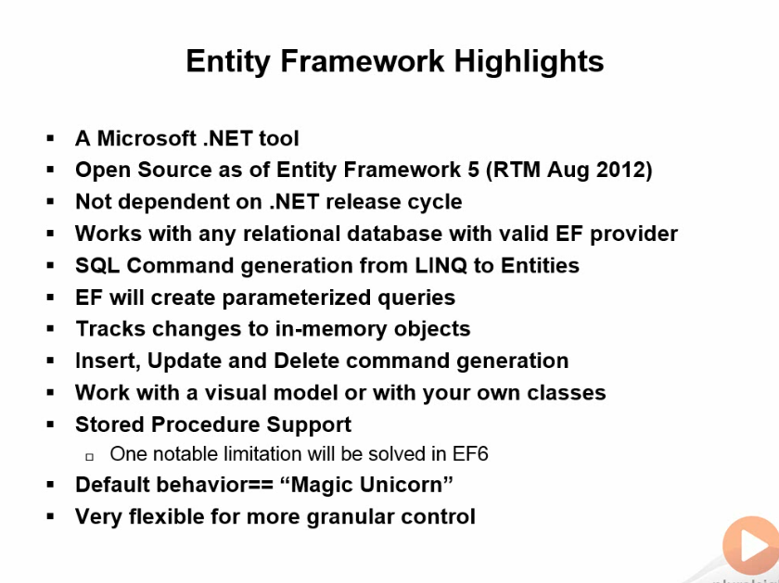

Work flow:

Database first: In turn, the Designer will generate code classes for you to use in the application along

with a context which manages those classes in behalf of Entity Framework

model first:You can also start with a blank model and design the model and generate the database from there

As long as the context is aware of the objects, it will keep track of the changes you make. If it's a disconnected application, we do have to do a little extra work when reconnecting the data to the context

Savechanges method:And they are executed in a transaction, so that will roll back if anything fails

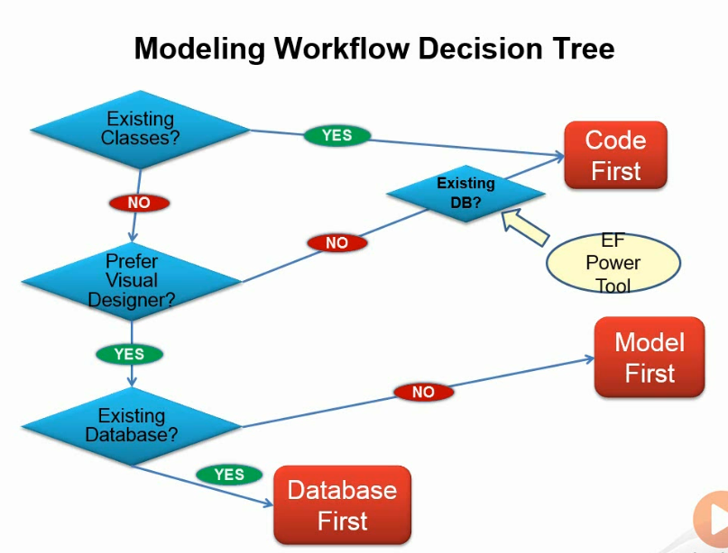

We got generated classes from those complex types that represent the results of this functions and stored procedures.

I'm using Entity Framework Profiler from Hibernating Rhinos,--it’s a very useful tool

#endregion pluralsight – Entity framework

#region asp.net mvc4 高级编程 and building application with MVC

By convention, the Views directory contains a folder per controller, with the same name as the controller,

but without the Controller suffix. Thus, for the HomeController, there’s a folder in the

views directory named Home.

In some situations, you might even want to specify a view in a completely different directory

structure. You can use the tilde syntax to provide the full path to the view, as follows:

public ActionResult Index() {

ViewBag.Message = "Modify this template to jump-start

your ASP.NET MVC application.";

**return View("~/Views/Example/Index.cshtml");**

}

The ViewBag is a dynamic wrapper around ViewData. It allows you to set values as follows:

ViewBag.CurrentTime = DateTime.Now;

Thus, ViewBag.CurrentTime is equivalent to ViewData["CurrentTime"].

For Razor view engines, specifying a layout is not necessary if you choose to use the default layout because

the layout is already specified in the _ViewStart.cshtml fi le. However, this option can be used to override the default Layout file.

The key transition character in Razor is the “at” sign (@). This single character is used to transition

from markup to code and sometimes also to transition back

<h1>Listing @stuff.Length items.</h1>

Razor is smart enough to know that the space character after the expression is not a valid identifier,

so it transitions smoothly back into markup.

Fortunately, Razor also supports explicit code expressions by wrapping them in parentheses:

<span>@(rootNamespace).Models</span>

This tells Razor that .Models is literal text and not part of the code expression.

<span>support@megacorp.com</span>

At first glance, this seems like it would cause an error because @megacorp.com looks like a valid

code expression where we’re trying to print out the com property of the megacorp variable.

Fortunately, Razor is smart enough to recognize the general pattern of an e-mail address and will

leave this expression alone.

When you have an action with a parameter, the MVC runtime uses a model binder to build the

parameter. The model binder can look at route data, the query string, and the form collection, and you can add custom value providers if you so desire.

The routing engine is the component that fi nds the ID value in the URL /StoreManager/ Edit/8, but it is a model binder that converts and moves the value from route data into the id parameter.

**TryUpdateModel(album);**

**if (ModelState.IsValid)**

while model state is useful for your own debugging purposes, it’s primarily used to display error messages to the user indicating why their data entry failed. In the next two chapters you will see how model state allows HTML helpers and the MVC validation features to work together with model binding.

You can also give the method attribute the value post, in which case the browser does not place the

input values into the query string, but places them inside the body of the HTTP request instead

Helpers also correctly encode attributes, build proper URLs to the right resources, and set the names of input elements to simplify model binding. Helpers are your friends!

If you want to avoid some reflection overhead and generate the SelectListItem collection yourself,

you can use the LINQ Select method to project Genres into SelectListItem objects:

public ActionResult Edit(int id)

{

var album = storeDB.Albums.Single(a => a.AlbumId == id);

**ViewBag.Genres =**

**storeDB.Genres**

**.OrderBy(g => g.Name)**

**.AsEnumerable()**

**.Select(g => new SelectListItem**

**{**

**Text = g.Name,**

**Value = g.GenreId.ToString(),**

**Selected = album.GenreId == g.GenreId**

**});**

return View(album);

}

When the helpers look inside ViewData, they can also look at properties of objects inside ViewData.

Change the previous controller action to look like the following:

public ActionResult Edit(int id)

{

ViewBag.Album = new Album {Price = 11};

return View();

}

You can use the following code to display a textbox with the album’s price:

@Html.TextBox("Album.Price")

<input id="Album_Price" name="Album.Price" type="text" value="11" />

Page 111

All the helpers you use to display form values also interact with ModelState. Remember,

ModelState is a byproduct of model binding and holds all validation errors detected during model

binding. Model state also holds the raw values the user submits to update a model.

Helpers used to render form fields automatically look up their current value in the ModelState dictionary.

The helpers use the name expression as a key into the ModelState dictionary. If an attempted

value exists in ModelState, the helper uses the value from ModelState instead of a value in view data

The ModelState lookup allows bad values to preserve themselves after model binding fails. For

example, if the user enters the value abc into the editor for a DateTime property, model binding

will fail and the value abc will go into model state for the associated property. When you re-render

the view for the user to fi x validation errors, the value abc will still appear in the DateTime editor,

allowing the users to see the text they tried as a problem and allowing them to correct the error.

another overloaded version of the constructor will take a Type parameter and two strings (which

can allow you to add a range to date and decimal properties, for example).

[Range(typeof(decimal), "0.00", "49.99")]

public decimal Price { get; set; }

[Remote("CheckUserName", "Account")]

public string UserName { get; set; }

public JsonResult CheckUserName(string username)

{

var result = Membership.FindUsersByName(username).Count == 0;

return Json(result, JsonRequestBehavior.AllowGet);

}

The controller action will take a parameter with the name of the property to validate, and return

a true or false wrapped in JavaScript Object Notation (JSON)

The second attribute is the Compare attribute. Compare ensures two properties on a model object

have the same value

[RegularExpression(@"[A-Za-z0-9._%+-]+@[A-Za-z0-9.-]+\.[A-Za-z]{2,4}")]

public string Email { get; set; }

**[Compare("Email")]**

public string EmailConfirm { get; set; }

when MVC execute validation?

By default, the ASP.NET MVC framework executes validation logic during model binding

the model binder runs implicitly when you have parameters to an action

method:

[HttpPost]

**public ActionResult Create(Album album)**

{

// the album parameter was created via model binding

// ..

}

You can also explicitly request model binding using the UpdateModel or TryUpdateModel methods

of a controller:

[HttpPost]

public ActionResult Edit(int id, FormCollection collection)

{

var album = storeDB.Albums.Find(id);

**if(TryUpdateModel(album))**

{

// ...

}

}

The model binder catches all the failed validation rules and places them into model state.

Not only does model state contain all the values a user attempted to put into model properties, but model state also contains all the errors associated with each property(and any errors associated with the model object itself).

var lastNameErrorMessage = ModelState["LastName"].Errors[0].ErrorMessage;

custom annotation => 129 页

[ScaffoldColumn(false)]

public string Username { get; set; }

steal you cookie and how to handle this?

You can stop script access to all cookies in your site by adding a simple flag: HttpOnly. You can set

this in the web.config, as follows:

<httpCookies domain="" httpOnlyCookies="true" requireSSL="false" />

Open redirection – security problem, use codes below to solve:

private ActionResult RedirectToLocal(string returnUrl)

{

if (Url.IsLocalUrl(returnUrl))

{

return Redirect(returnUrl);

}

else

{

**// Actions on for detected open redirect go here.**

**string message = string.Format(**

**"Open redirect to to {0} detected.", returnUrl);**

**ErrorSignal.FromCurrentContext().Raise(**

**new System.Security.SecurityException(message));**

**return RedirectToAction("SecurityWarning", "Home");**

}

}

*Unobtrusive JavaScript* is the practice of keeping JavaScript code separate from markup

default _Layout view in a new ASP.NET MVC 4 application will include a section specifi cally for you to include scripts that depend on jQuery. The name of the section is “scripts,” and it will appear after jQuery is loaded so that your

custom scripts can take a dependency on jQuery.

Inside of any content view, you can now add a scripts section to inject view-specifi c scripts into

the header:

@section scripts{

<script src="~/Scripts/MusicScripts.js")

></script>

}

The files with “unobtrusive” in the name are fi les written by Microsoft. The unobtrusive scripts

integrate with jQuery and the MVC framework to provide the unobtrusive JavaScript features mentioned

earlier. You’ll need to use these fi les if you want to use Ajax features of the ASP.NET MVC

framework, and you’ll also see how to use these scripts in this chapter.

Another script you’ll find in the Scripts directory is a Modernizr script. Modernizr is a JavaScript

library that helps you build modern applications by modernizing older browsers. For example, one

important job of Modernizr is to enable the new HTML 5 elements (such as header, nav, and menu)

on browsers that don’t natively support HTML 5 elements (like Internet Explorer 6). Modernizr will

also allow you to detect if advanced features like geolocation and the drawing canvas are available

in a particular browser.

Knockout provides data-binding capabilities for those who want to use a Model-View-ViewModel (MVVM)

design pattern for their JavaScript code and data on the client.

Behind the scenes, these Ajax helpers depend on the unobtrusive MVC extensions for jQuery. To

use the helpers, you need to have the jquery.unobtrusive-ajax script present.

<div id="dailydeal">

@Ajax.ActionLink("Click here to see today's special!",

"DailyDeal",

new AjaxOptions{

UpdateTargetId="dailydeal",

InsertionMode=InsertionMode.Replace,

HttpMethod="GET"

})

</div>

public ActionResult DailyDeal()

{

var album = GetDailyDeal();

return PartialView("_DailyDeal", album);

}

If you look at the rendered markup for the action link, you’ll fi nd the following:

<a data-ajax="true" data-ajax-method="GET" data-ajax-mode="replace"

data-ajax-update="#dailydeal" href="/Home/DailyDeal">

Click here to see today&#39;s special!

</a>

The purpose of the jquery.unobtrusive-ajax file you added to the application is to look for

specific data dash attributes and then manipulate the element to behave differently

client validate:

1. Reference scripts as follows

<script src="~/Scripts/jquery.validate.min.js")

></script>

<script src="~/Scripts/jquery.validate.unobtrusive.min.js")

></script>

The second script tag includes Microsoft’s unobtrusive adapter for jQuery validation. The code

inside this script is responsible for taking the client-side metadata the MVC framework emits and

adapting (transforming) the metadata into data jQuery validation will understand

1. Use html helper

The helper builds out inputs for a model based on metadata.

When TextBoxFor sees validation metadata, such as the Required and StringLength annotations

on Price and Title, it can emit the metadata into the rendered HTML. The following markup is

the editor for the Title property:

<input

data-val="true"

data-val-length="The field Title must be a string with a maximum length of 160."

data-val-length-max="160" data-val-required="An Album Title is required"

id="Title" name="Title" type="text" value="Greatest Hits" />

End asp.net mvc4 高级编程 end

@@ Define a parameter in the action, and mvc will try to find the value for this parameter auto…

it will look all around the request it will look in routing data, It will also look in the query string and it will look in posted form values

autocomplete: a very useful practise

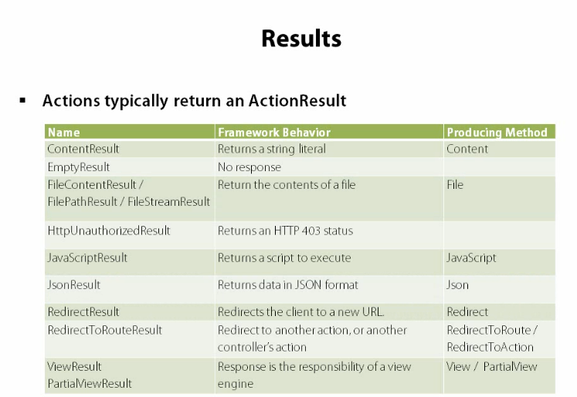

*****over post: start

for example, in an edit page, there’s one property(let me say price) I don’t what user to edit, so this property Doesn’t show on the page, but user edit the query string, like xxx?Price=0.1, still, the property price of the model will be set the value of 0.1, and will store in the database

An easy way to handle this is to use [bind(exclude=”Price”)]

PS: I have a document named <6 Ways To Avoid Mass Assignment in ASP.NET MVC> or the url: <http://odetocode.com/blogs/scott/archive/2012/03/12/complete-guide-to-mass-assignment-in-asp-net-mvc.aspx> to solve this problem

======over post end

****** custom Validation in mvc start

1. property validation: define an attribute deriving from ValidationAttribute
2. model level validation: make the model derived form IValidatableObject

custom validation in mvc end

#endregion building application with MVC

#region Hybrids clr, thread,some books

Appdomain is a logical container for a set of assemblies

The whole purpose of app domain is to provide isolation

#endregion

Region entity framework from professional c sharp

With EF, we can use strongly typed c sharp code to access relational databse(from mvc-EF)

And I don’t need to worry about sql connection, commands,parameters, and readers

The ADO.NET Entity Framework provides a mapping from the relational database schema to objects.

The ADO.NET Entity Framework makes use of Entity SQL to define entity-based queries to the store. LINQ

to Entities makes it possible to use the LINQ syntax to query data. An object context keeps knowledge about

entities that are changed, to have information when the entities should be written back to the store.

The layers that need to be defined are as follows:

➤ *Logical* — This layer defines the relational data.(leo: 数据库结构) store schema definition language ssdl

➤ *Conceptual* — This layer defines the .NET classes.(leo:c# 类结构) conceptual schema xx csdl

➤ *Mapping* — This layer defines the mapping from .NET classes to relational tables and associations. msl

(leo:可以以”xml”的形式打开edmx，就可以看到以上三个layter)

The ObjectContext class provides several services to the caller:

It keeps track of entity objects that are already retrieved. If the object is queried again, ➤ it is taken from

the object context.

➤ It keeps state information about the entities. You can get information about added, modified, and

deleted objects.

➤ You can update the entities from the object context to write the changes to the underlying store.

The ADO.NET Entity Framework supports several kinds of relationships, some of which are

shown here, including Table-per-Hierarchy (TPH) and Table-per-Type (TPT).

Multiplicity can be one-to-one, one-to-many, or many-to-many.

Table per hierarchy:(in <professional c#>, there are credit payment, cash payment class, for different type of payment)

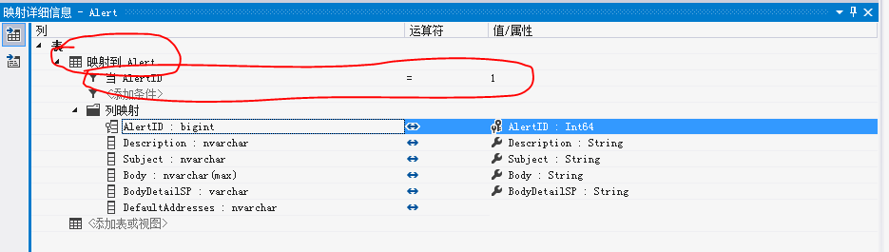

Eager loading(贪婪加载),delayed loading

By default, relationships are lazy loaded on request when the property LazyLoadingEnabled from the

ContextOptions is set to true. You have other options as well. Relationships can also be *eager loaded* or

*delayed loaded*.

Eager loading means that the relationship is loaded at the same time the parent objects are loaded. The

orders are loaded immediately after adding a call to the Include() method. It passes the relationship name

with ObjectSet<TEntity>, as shown with the Customers property:

foreach (Customer customer in data.Customers.**Include("Orders"))**

{

Console.WriteLine("{0}", customer.CompanyName);

foreach (Order order in customer.Orders)

{

Console.WriteLine("\t{0} {1:d}", order.OrderID, order.OrderDate);

}

}

Eager loading has the advantage that if all related objects are needed, then fewer requests to the database

are done. Of course, if not all related objects are needed, lazy or delayed loading is preferred.

Delayed loading needs an explicit call to the Load() method of the EntityCollection<T> class. Using this

method, the option LazyLoadingEnabled can be set to false. With the following code snippet, the orders

are loaded with the Load() method if they are not loaded with the IsLoaded property:

if (!customer.Orders.IsLoaded)

customer.Orders.Load();

using ObjectStateManagerChanged event

private static void TrackingDemo()

{

using (var data = new Formula1Entities())

{

data.ObjectStateManager.ObjectStateManagerChanged +=

ObjectStateManager_ObjectStateManagerChanged;

Racer niki1 = data.Racers.Where("it.Country='Austria' && it.Lastname='Lauda'").

First();

Racer niki2 = data.Racers.Where("it.Country='Austria'").

OrderBy("it.Wins DESC").First();

if (Object.ReferenceEquals(niki1, niki2))

{

Console.WriteLine("the same object");

}

}

}

static void ObjectStateManager_ObjectStateManagerChanged(object sender,

CollectionChangeEventArgs e)

{

Console.WriteLine("Object State change — action: {0}", e.Action);

Racer r = e.Element as Racer;

if (r != null)

Console.WriteLine("Racer {0}", r.Lastname);

}

Change information good sample

{

using (var data = new Formula1Entities())

{

var jaime = new Racer

{

Firstname = "Jaime",

Lastname = "Alguersuari",

Country = "Spain",

Starts = 0

};

data.Racers.AddObject(jaime);

Racer fernando = data.Racers.Where("it.Lastname='Alonso'").First();

fernando.Starts++;

DisplayState(EntityState.Added.ToString(),

data.ObjectStateManager.GetObjectStateEntries(EntityState.Added));

DisplayState(EntityState.Modified.ToString(),

data.ObjectStateManager.GetObjectStateEntries(EntityState.Modified));

ObjectStateEntry stateOfFernando =

data.ObjectStateManager.GetObjectStateEntry(fernando.EntityKey);

Console.WriteLine("state of Fernando: {0}",

stateOfFernando.State.ToString());

foreach (string modifiedProp in stateOfFernando.GetModifiedProperties())

{

Console.WriteLine("modified: {0}", modifiedProp);

Console.WriteLine("original: {0}",

stateOfFernando.OriginalValues[modifiedProp]);

Console.WriteLine("current: {0}",

stateOfFernando.CurrentValues[modifiedProp]);

}

}

}

static void DisplayState(string state, IEnumerable<ObjectStateEntry> entries)

{

foreach (var entry in entries)

{

var r = entry.Entity as Racer;

if (r != null)

{

Console.WriteLine("{0}: {1}", state, r.Lastname);

}

}

}

Based on all the change information with the help of the ObjectStateManager, the added, deleted, and

modified entity objects can be written to the store with the SaveChanges() method of the ObjectContext class. To verify changes within the object context, you can assign a handler method to the SavingChanges event

This event is fired before the data is written to the store, so you can add

some verification logic to see if the changes should be really done. SaveChanges() returns the number of

entity objects that have been written.

Concurrency problem

What happens if the records in the database that are represented by the entity classes have been changed

after reading the record? The answer depends on the ConcurrencyMode property that is set with the

model. With every property of an entity object, you can configure the ConcurrencyMode to Fixed or

None. The value Fixed means that the property is validated at write time to determine if the value was

not changed in the meantime. None — which is the default — ignores any change. If some properties

are configured to the Fixed mode, and data changed between reading and writing the entity objects, an

OptimisticConcurrencyException occurs.(good)

在System.Data.Metadata.Edm 命名空间中，存在ConcurencyMode 枚举，用于指定概念模型中的属性的并发选项。  
ConcurencyMode 有两个成员:

|  |  |
| --- | --- |
| **成员名称** | **说明** |
| None | 在写入时从不验证此属性。 这是默认的并发模式。 |
| Fixed | 在写入时始终验证此属性。 |

开发人员可以为对象的每个属性定义不同的 ConcurencyMode 选项，选项可以在*.csdl 找看到：

<EntityType Name="Person">

<Key><PropertyRef Name="Id" /></Key>

<Property Type="String" Name="FirstName" MaxLength="50" FixedLength="false" Unicode="true" **ConcurrencyMode**="Fixed" />

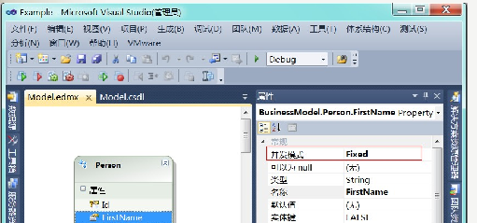

You can deal with this exception by invoking the Refresh() method to read the actual information

from the database into the object context. This method accepts two refresh modes configured by a

RefreshMode enumeration value: ClientWins or StoreWins. StoreWins means that the actual information

is taken from the database and set to the current values of the entity objects. ClientWins means that the

database information is set to the original values of the entity objects, and thus the database values will

be overwritten with the next SaveChanges. The second parameter of the Refresh() method is either a

collection of entity objects or a single entity object. You can decide the refresh behavior entity by entity:

private static void ChangeInformation()

{

//...

int changes = 0;

try

{

changes += data.SaveChanges();

}

catch (OptimisticConcurrencyException ex)

{

data.Refresh(RefreshMode.ClientWins, ex.StateEntries);

changes += data.SaveChanges();

}

Console.WriteLine("{0} entities changed", changes);

Endregion

利用 ObjectContext.Refresh 方法，Refresh 第一参数是一个枚举：  
1) RefreshMode.StoreWins 表示放弃本地数据，接受DB的数据。  
2) RefreshMode.ClientWins 表示继续保持当前的数据，直到调用SaveChanges() 以当前数据更新到DB

[Refresh](http://msdn.microsoft.com/zh-cn/library/system.data.objects.objectcontext.refresh.aspx) 具有两种用途，一种是允许使用数据源中的数据刷新对象，另一种是作为解决冲突的机制。 有关更多信息，请参见[Saving Changes and Managing Concurrency (Entity Framework)](http://msdn.microsoft.com/zh-cn/library/bb738618.aspx)。

刷新对象的顺序具有不确定性。

在调用 [Refresh](http://msdn.microsoft.com/zh-cn/library/system.data.objects.objectcontext.refresh.aspx) 方法后，会始终使用数据源值更新对象的原始值，但是也可能不会使用数据源值更新当前值。 这取决于 [RefreshMode](http://msdn.microsoft.com/zh-cn/library/system.data.objects.refreshmode.aspx)。 [StoreWins](http://msdn.microsoft.com/zh-cn/library/system.data.objects.refreshmode.aspx) 模式意味着应将对象更新为与数据源值匹配。 [ClientWins](http://msdn.microsoft.com/zh-cn/library/system.data.objects.refreshmode.aspx) 值意味着仅保持对象上下文中的更改，即使数据源中发生了其他更改也是如此。

若要确保已由数据源端逻辑更新了对象，可以在调用 [SaveChanges](http://msdn.microsoft.com/zh-cn/library/system.data.objects.objectcontext.savechanges.aspx) 方法后，使用 [StoreWins](http://msdn.microsoft.com/zh-cn/library/system.data.objects.refreshmode.aspx) 值调用 [Refresh](http://msdn.microsoft.com/zh-cn/library/system.data.objects.objectcontext.refresh.aspx) 方法

A linq to entity sample:

using (var data = new Formula1Entities())

{

var query = from r in data.Racers

from rr in r.RaceResults

where rr.Position <= 3 && rr.Position >= 1 &&

r.Country == "Switzerland"

group r by r.Id into g

let podium = g.Count()

orderby podium descending

select new

{

Racer = g.FirstOrDefault(),

Podiums = podium

};

foreach (var r in query)

{

Console.WriteLine("{0} {1} {2}", r.Racer.Firstname, r.Racer.Lastname,

r.Podiums);

}

}

#region Linq from professional c#

The compiler modifi es the LINQ query to invoke methods instead. LINQ offers various extension methods

for the IEnumerable < T > interface so you can use the LINQ query across any collection that implements

this interface.

An *extension method* is defined as a static method where the first parameter defines the type it extends

and it is declared in a static class.

The extension method cannot access private members of the type it extends. Calling an extension method is just a new syntax of invoking a static method.(看来是compiler会把extension方法转成直接调用static method)

Compound from

var ferrariDrivers = from r in Racers

from c in r.Cars

where c == "Ferrari"

orderby r.LastName

select r.FirstName + " " + r.LastName;

var racers = (from r in Formula1.GetChampions()

orderby r.Country, r.LastName, r.FirstName

select r).Take(10);

=>

var racers = Formula1.GetChampions().

OrderBy(r => r.Country).

ThenBy(r => r.LastName).

ThenBy(r => r.FirstName).

Take(10);

(good)The clause group r by r.Country into g groups all the racers based on the Country property and defines

a new identifier g that can be used later to access the group result information. The result from the group

clause is ordered based on the extension method Count() that is applied on the group result, and if the

count is the same, the ordering is done based on the key. This is the country because this was the key used

for grouping. The where clause filters the results based on groups that have at least two items, and the

select clause creates an anonymous type with Country and Count properties:

var countries = from r in Formula1.GetChampions()

group r by r.Country into g

orderby g.Count() descending, g.Key

where g.Count() >= 2

select new {

Country = g.Key,

Count = g.Count()

};

foreach (var item in countries)

group: very good sample

var countries = from r in Formula1.GetChampions()

group r by r.Country into g

orderby g.Count() descending, g.Key

where g.Count() >= 2

select new

{

Country = g.Key,

Count = g.Count(),

Racers = from r1 in g

orderby r1.LastName

select r1.FirstName + " " + r1.LastName

};

Join statement : join t in teams on r.Year equals t.Year

The aggregate operators such as Count() , Sum() , Min() , Max() , Average() , and Aggregate() do not

return a sequence but a single value instead.

Wins = (from r1 in collection select r1.Wins).Sum()

#end region

#region execution plan

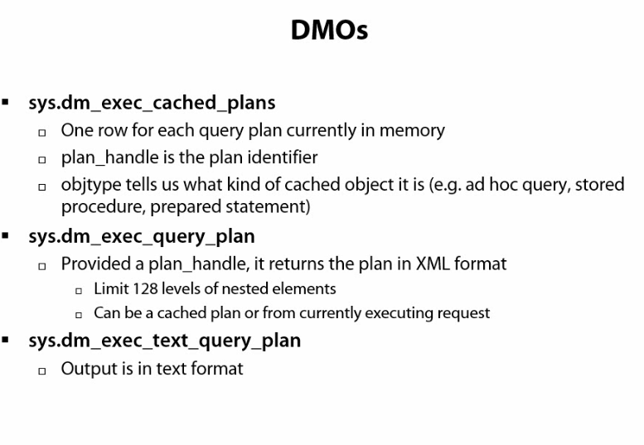

Sql sentry is a good tool for sql server performance tuning

#endregon execution plan

#region sql server fine tune

Avoid use select *,

1. it retrieve unnecessary data , increase network traffic.
2. Damage to clustered usage, may not use optimal usage.

#endregion sql server fine tune

Specification:

I use ***** to mark up the important or difficult part that I need to pay more attention to, so made this markup thtat I could navigate to it easily